**Topic:** The Legacy of Pierre de Fermat

**Notes on Topic:**

We have seen Euler’s evaluating of infinite series, this work falls under the category of “analysis” where his discoveries were important and profound

Euler also played a strong hand in number theory

We have encountered number theory in chapter 3 with Euclid, with Diophantus and Mersenne and in Chapter 7 with the work of Fermat

As we know, Fermat was not keen on providing proofs for the somewhat extravagant conjectures he would throw about, and in the century separating Euler and Fermat, not a lot of work had been done in the theory of numbers -- this absence of progress is in part due to the excitement of the recently discovered calculus, in part the perceived lack of real-world application of the theory of numbers, and in part that Fermat’s claims were too difficult for many mathematicians to tackle

Euler’s enthusiasms was nurtured by Christian Goldbach (his conjecture has been mentioned in Chapter 3 epilogue)

It was Goldbach that brought many of Fermat’s unproved statements to Euler

Euler was less than enthused to examine this subject, at first, but his general curiosity and Goldbach’s persistence forced Euler to take a look

Andre Weil notes, “a substantial part of Euler’s [number theoretic] work consisted in no more, and no less, than getting proofs for Fermat’s statements.”

**For example:** Euler proved Fermat’s statement

*For p>2 where p is prime, p can be written p=4k+1 or p=4k+3, for some integer k.*

*If p=4k+1, p can be written as the sum of two perfect squares in only one way.*

*If p=4k+3, p cannot be expressed as the sum of two perfect squares.*

This is unintuitive and surprising that primes can be split between those that are the sum of two perfect squares, and those that are not.

**For example:** Euler had done work (we saw in Chapter 3) with even perfect numbers, and along those lines he discovered a property of numbers where-in-by two numbers can be *amicable*. These are pairs of numbers whose sum of proper divisors are equal. Prior to Euler’s work, there were three known amicable numbers. Euler managed to find 57 others. He found a recipe for generating these numbers.

**For example:** Euler proved one of the most important assertions of Fermat, *if a is any whole number, and p is a prime not a factor of a, then p is a factor of $a^{p-1}-1$* . As was custom, Fermat claimed he had a proof, but told his correspondents that he would send it if he didn’t “fear it being too long”. This has come to be known as the “little Fermat theorem”.

Euler needed a few key ingredients to cook up this proof:

1. If p is prime that divides evenly into the product a*b*c*...*d then p must divide evenly at least one of the factors of a, or b, or c, or d
2. If p is prime and a is any whole number, then the expression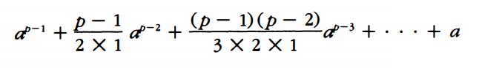is a whole number as well.

We shall not prove this statement, but instead will investigate its truth for a particular example or two.

**show truth for a = 13 and p = 7**

**show false for a = 13 and p = 4** implying p must be prime in order for this to hold true

c) The final ingredient, Newton’s binomial theorem on ${(a+1)}^{p}$ which Euler was well versed in

We shall attack little Fermat in a series of four steps, each following into the next

**Euler’s Proofs:**

**Theorem:** If p is prime and a is any whole number, then ${(a+1)}^{p}-(a^{p}+1)$

is evenly divisible by p.

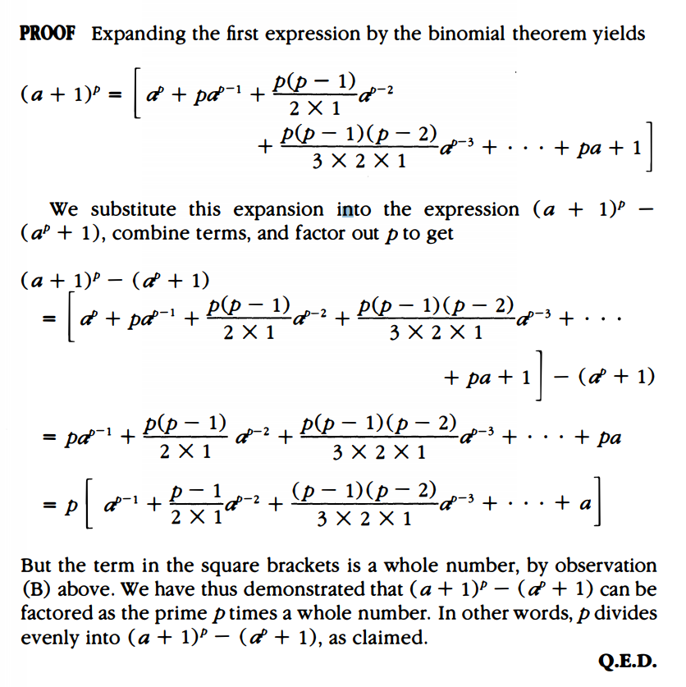

**Theorem:** If p is prime and if $a^{p}-a$ is evenly divisible by p, then so is ${(a+1)}^{p}-(a+1)$.

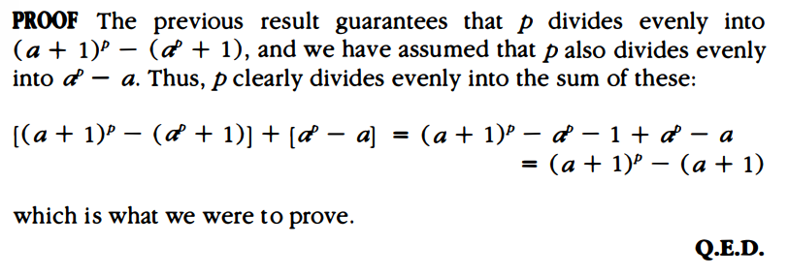

**Theorem:** If p is prime and a is any whole number, then p divides evenly into $a^{p}-a$.

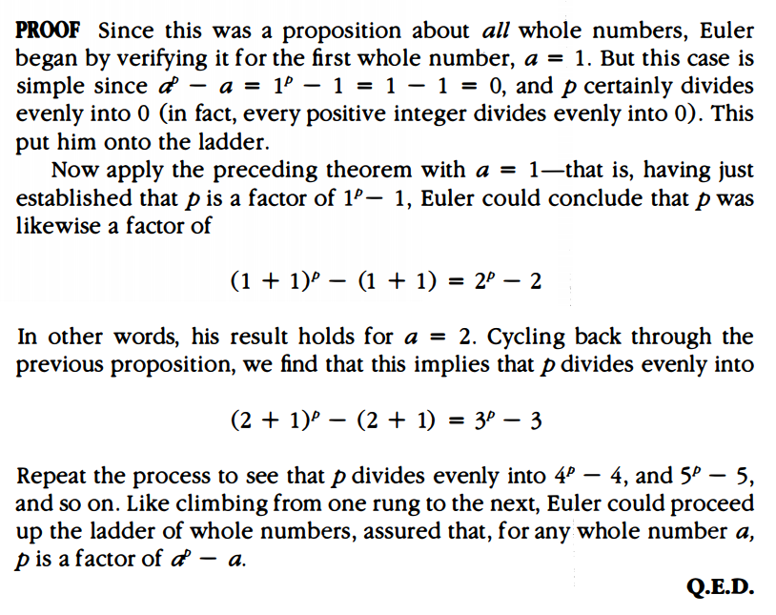

**Little Fermat Theorem:** If p is prime and a is a whole number which does not have p as a factor, then p divides evenly into $a^{p-1}-1$.

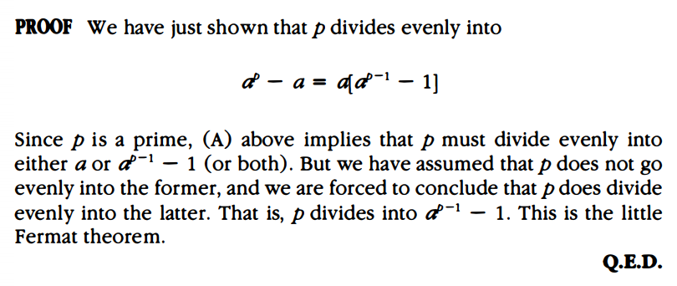

Euler’s argument was a gem, it combined old mathematics of Euclid with new mathematics of Newton and his Binomial expansion.

This proposition has been used in real world applications recently -- the design of some highly sophisticated encryption system for transmitting messages.

**Additional Suggested Reading**: None

**Assignment:** Homework 8 Problems, 113, 114, 116, 119, 121, 123, 127